**BUILD WITH MAVEN**

**We would be building the job then the artifacts would be pushed to artifactory server then deploy the artifact to the deployment server**

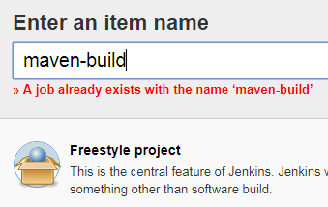

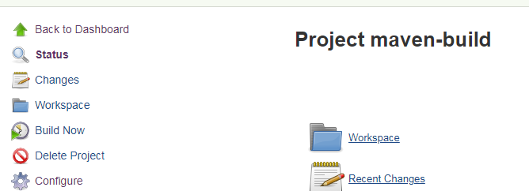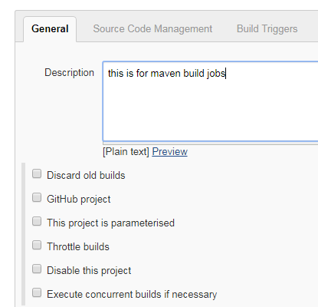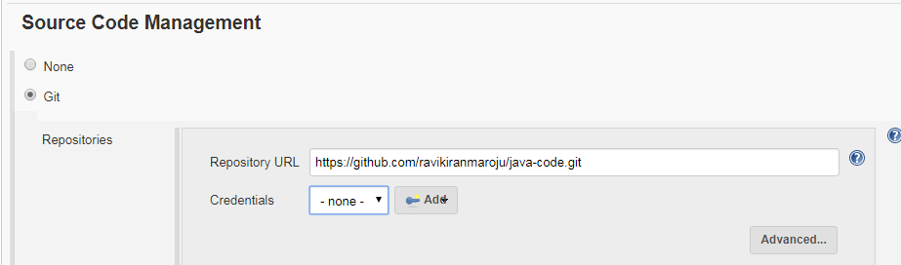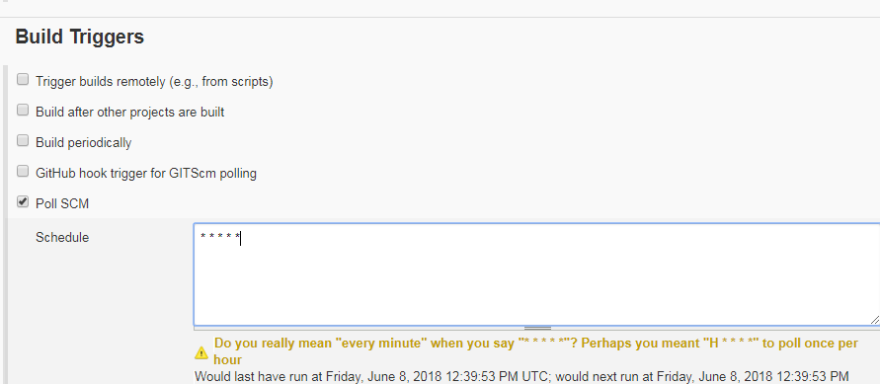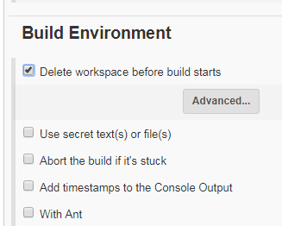

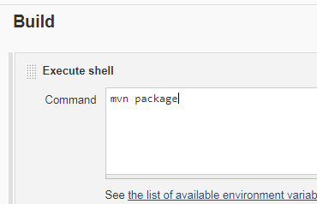

Maven should be installed in the jenkins server

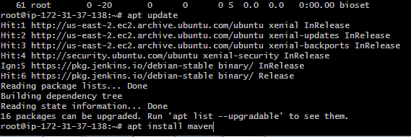

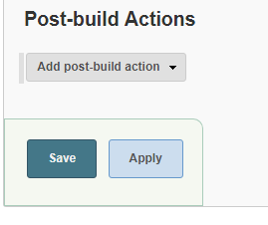

Artifactory should be installed

Install JFrog Artifactory

<https://hostpresto.com/community/tutorials/how-to-install-jfrog-artifactory-on-ubuntu-14-04/>

apt update

apt install default-jdk

wget -c -O- "https://bintray.com/user/downloadSubjectPublicKey?username=jfrog" | sudo apt-key add -

echo "deb https://bintray.com/artifact/download/jfrog/artifactory-debs trusty main" | sudo tee -a /etc/apt/sources.list.d/artifactory-oss.list

sudo apt-get update

sudo apt-get -y install jfrog-artifactory-oss

systemctl start artifactory.service

systemctl status artifactory.service

open it and configure for the first time

http://ec2-18-220-137-75.us-east-2.compute.amazonaws.com:8081

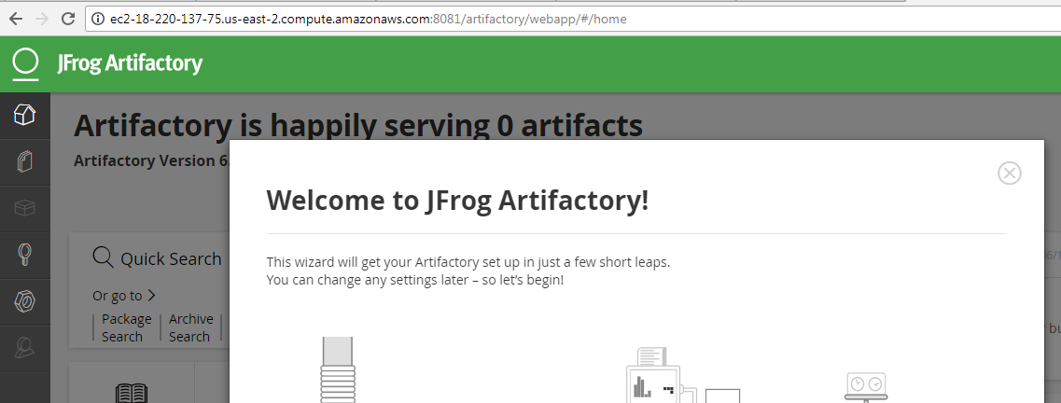

add password and skip remaining

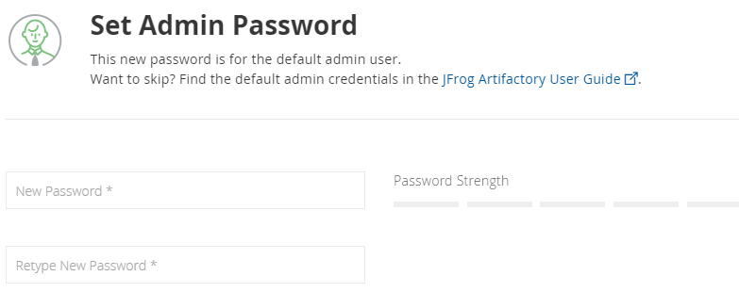

choose generic where in it has all the options like above choosing one equals to all



C:\Users\kaarthik\Desktop\jenkins-today\1e.PNG

Now we have to configure the artifactory server with Jenkins where what ever the outputs gets in the Jenkins server we need to push automatically to artifactory server

Now click on the artifactory job which u have create and click on SET ME UP



Now copy that

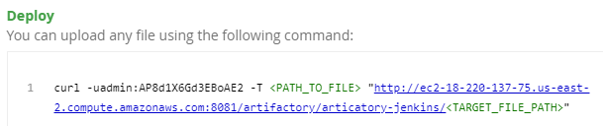

Now go to Jenkins click on job where u want to push and configure

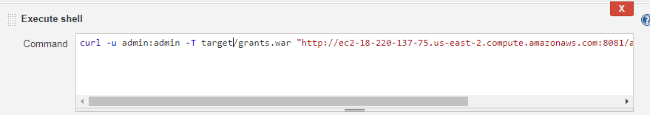

Now change the path username and password and target file name

EX:

curl -u admin:admin -T target/grants.war <http://ec2-18-220-137-75.us-east-2.compute.amazonaws.com:8081/artifactory/articatory-jenkins/grants.war>

Like this

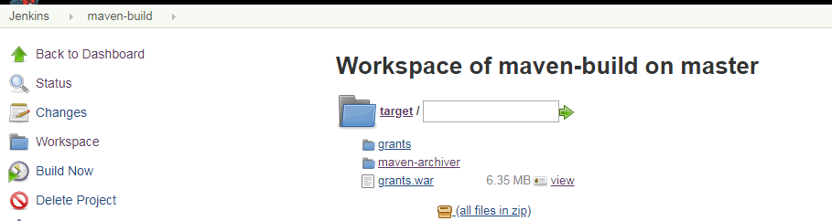

Now do a build

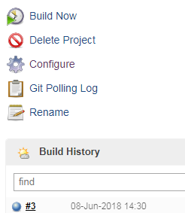

Then it should push to the artifactory server

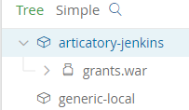

Now do a unit test ****LATER***

Now configure deployment server that means create a slave for this in Jenkins

WHY because we need to deploy the artifactory output to the deployment server

apt update

apt install default-jdk

Now create slave node

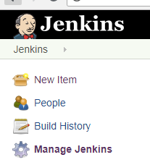C:\Users\kaarthik\Desktop\jenkins-today\4.PNG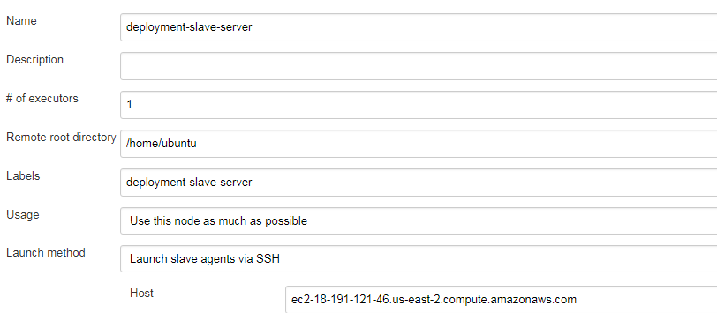

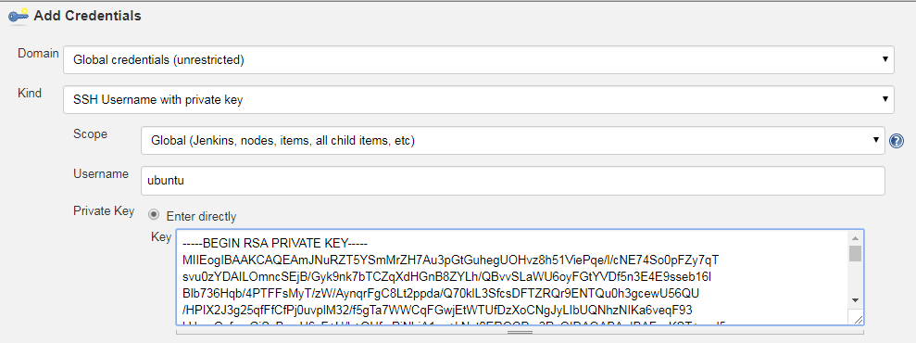



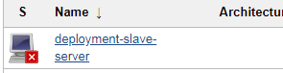

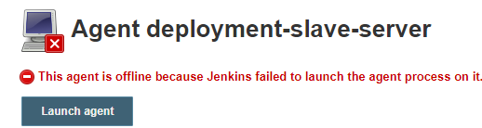

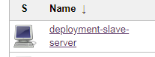

Now create a job

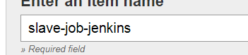

give the slave server name

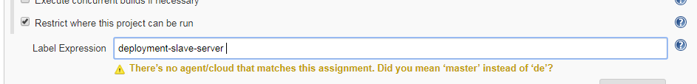

Now what we have to do is

install tomcat8 by apt update

cd to /var/lib/tomcat8/webapps

and download the files from artifactory server

For tomcat we have to create a configuration file by installing a plugin called “Text file operations” plugin

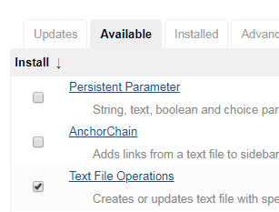

sudo apt update -y

sudo apt install tomcat8 tomcat8-admin tomcat8-users

cd /var/lib/tomcat8/webapps

sudo chmod 777 /var/lib/tomcat8/webapps

curl -u admin:admin -O <http://ec2-18-220-137-75.us-east-2.compute.amazonaws.com:8081/artifactory/articatory-jenkins/grants.war>

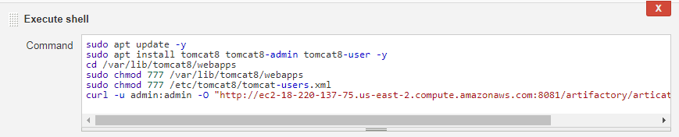

Now edit the file with the below

Now we have to assign credentials or access so do below

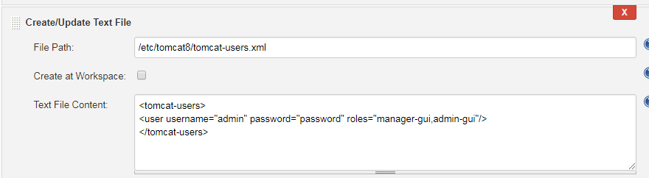

now add another step restart of tomcat8

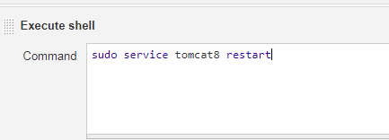

save and apply

Final step is to do Downstream project

click on first job and configure

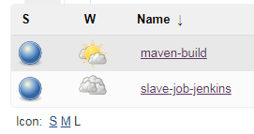

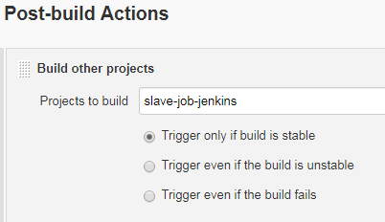

when 1st job is completed then it will trigger next job

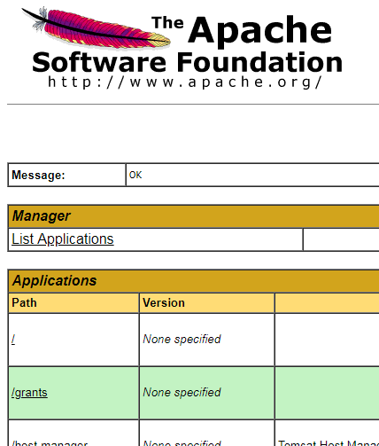

see /grants files have been pushed to tomcat

